SCENAERIO 01 : Verify login with valid credentials
TEST IID : TC_001
TEST STEPS: ENTER THE USERNAME WITH VALID PASSWARDS
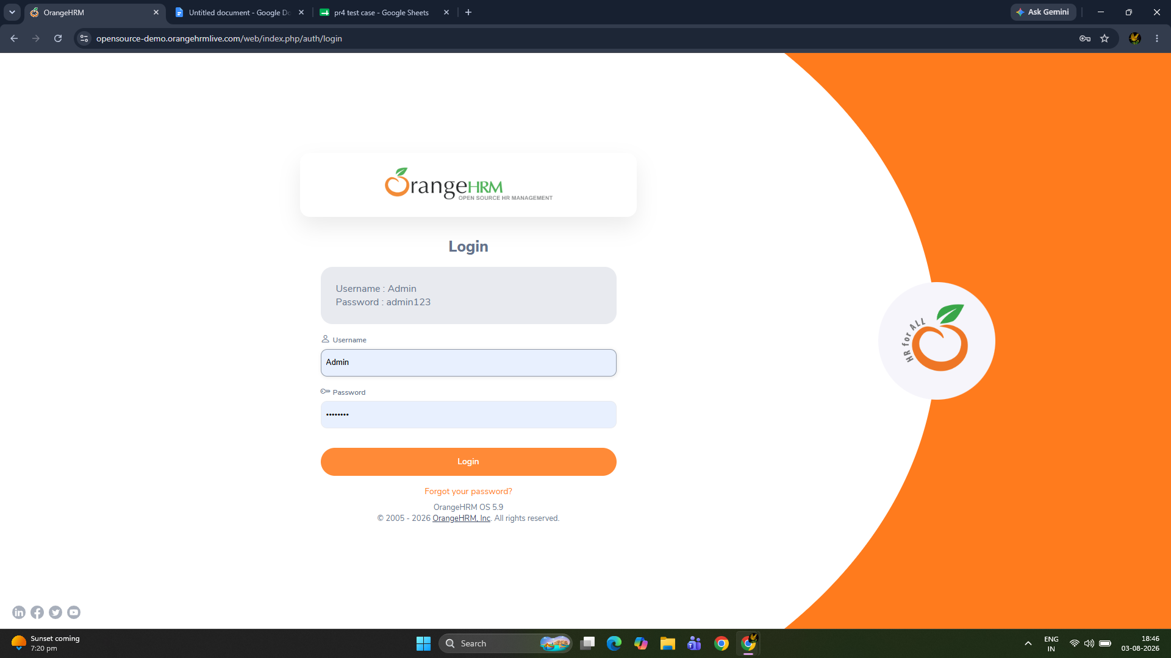
SCENAERIO 02 : Verify login with invalid passward
TEST IID : TC_002
TEST STEPS: ENTER THE USERNAME WITH VALID PASSWARDS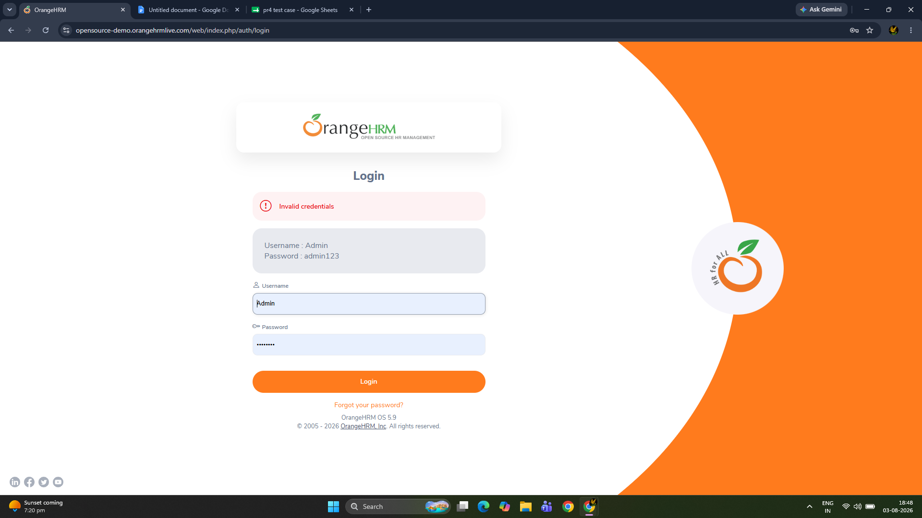
SCENAERIO 03 : Verify login with empty username
TEST IID : TC_003
TEST STEPS: ENTER PASSWARDS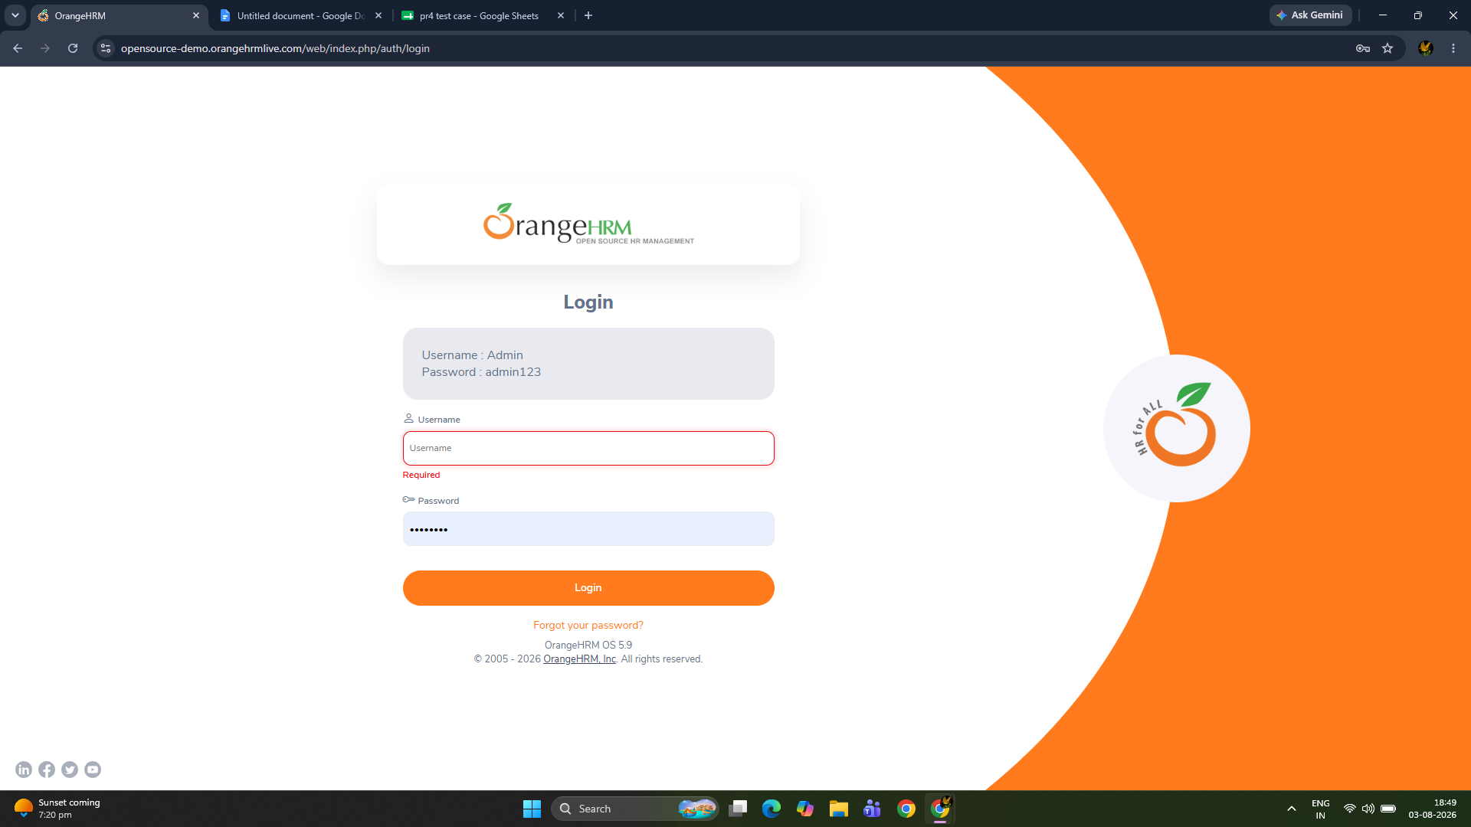
SCENAERIO 04 : Verify login with blank field
TEST IID : TC_004
TEST STEPS: leave blank both field
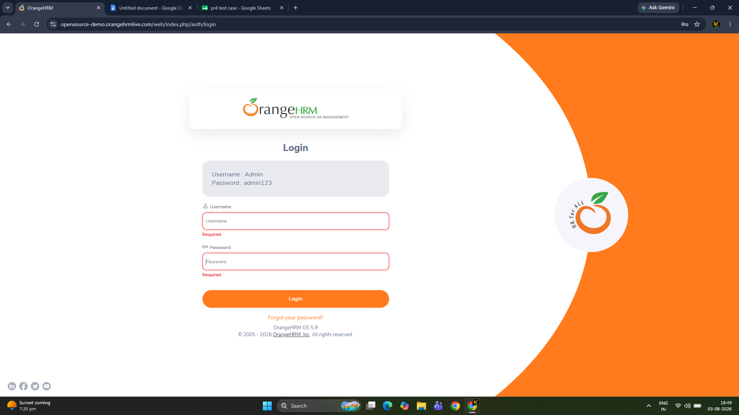
SCENAERIO 05 : logout functionality
TEST IID : TC_005
TEST STEPS: login> click profile> logout
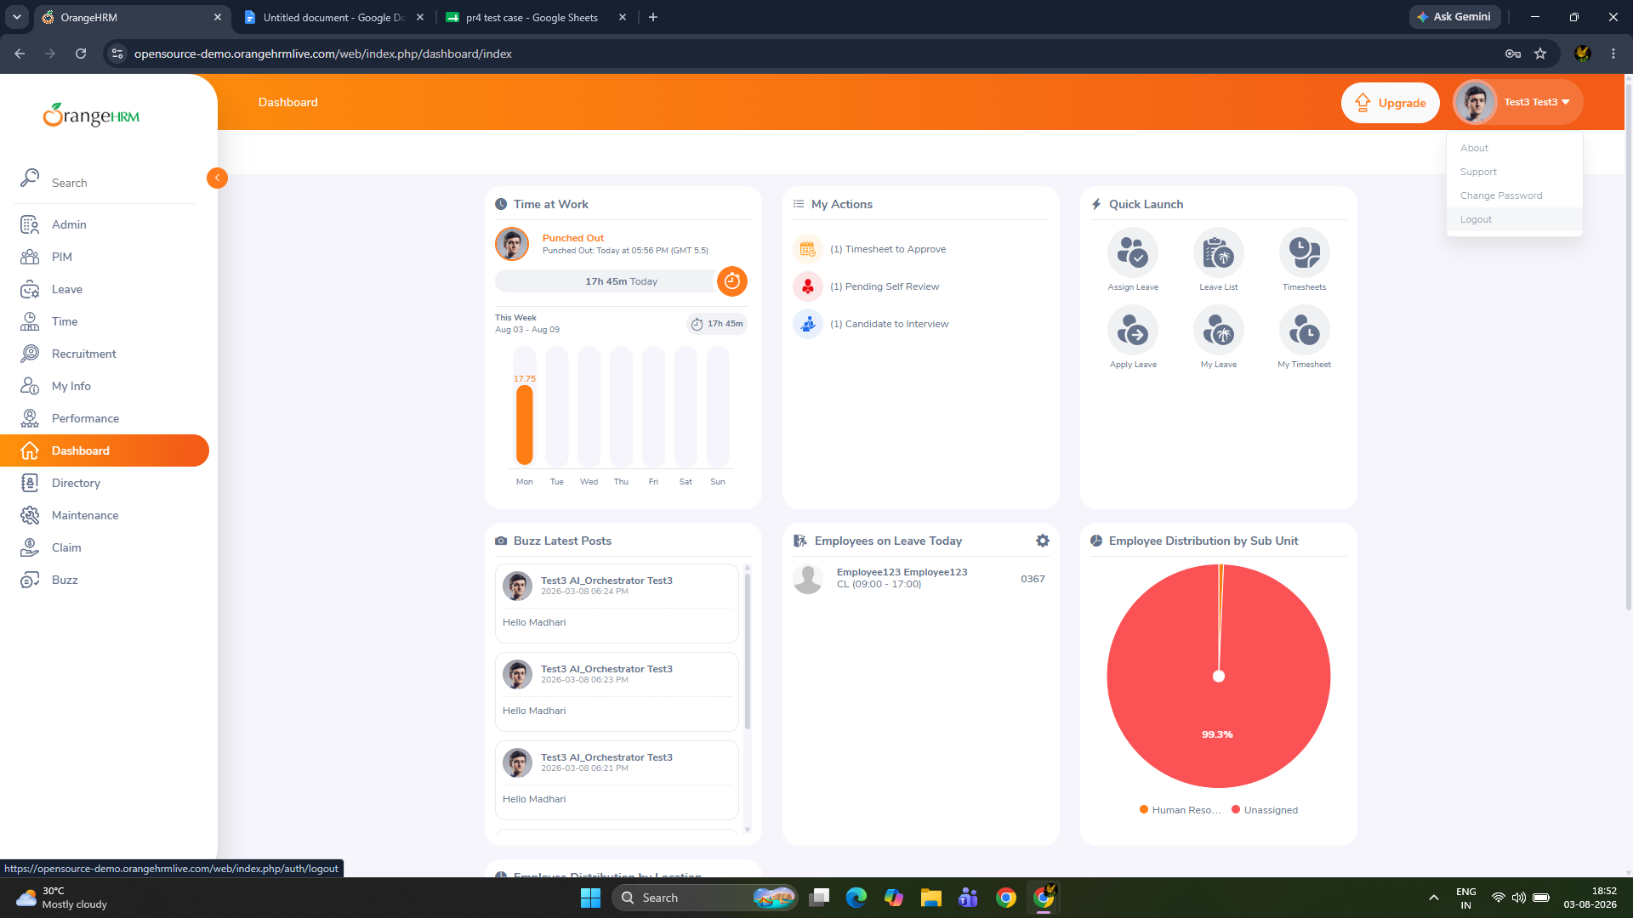
SCENAERIO 06 : Verify forgot password link
TEST IID : TC_006
TEST STEPS:Click Forgot Password >Enter username >Submit 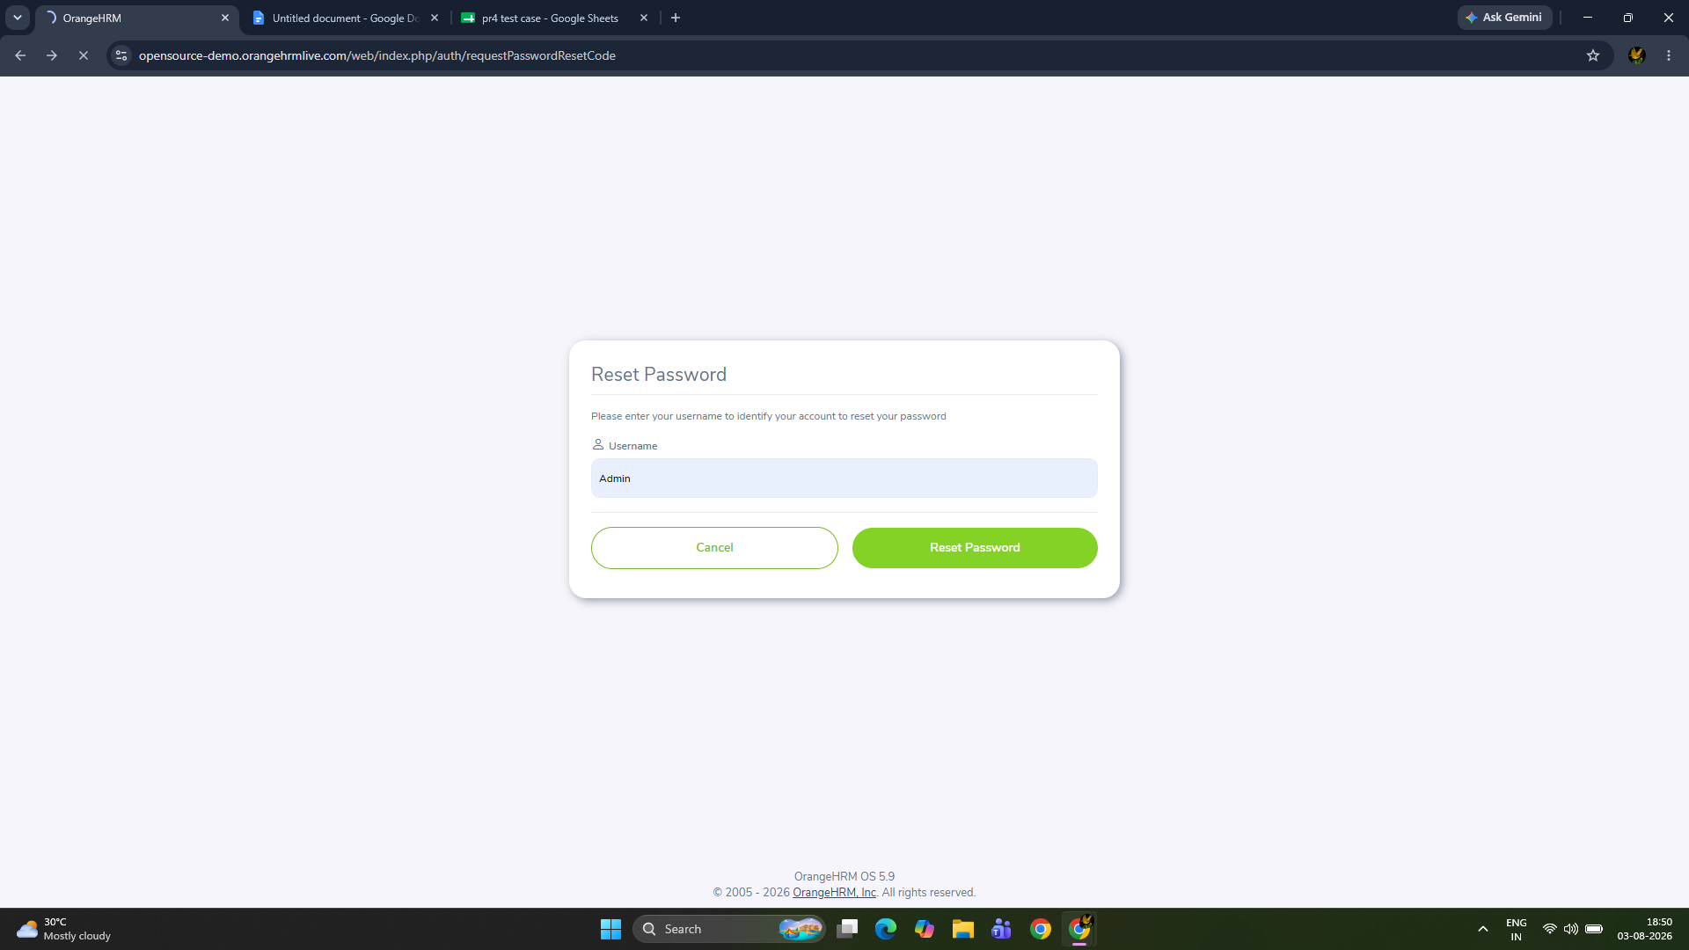
SCENAERIO 07 : Verify dashboard display
TEST IID : TC_007
TEST STEPS: login successfully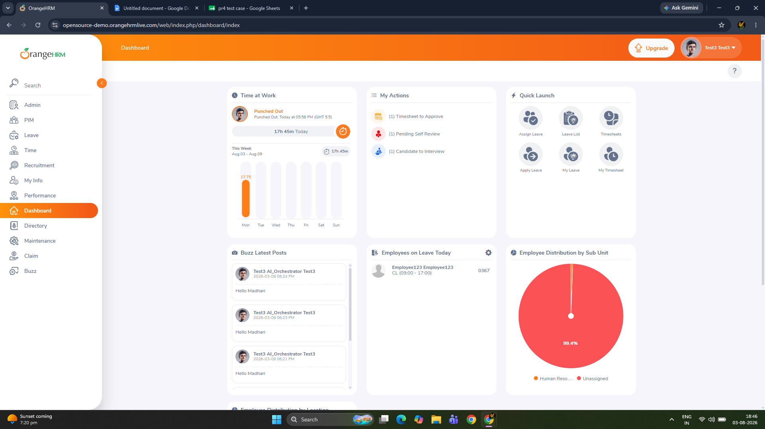
SCENAERIO 08 : Verify navigation to PIM module
TEST IID : TC_008
TEST STEPS: Login > Click PIM 